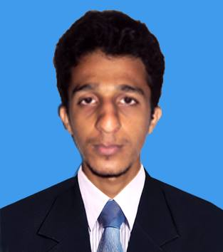W. Lahiru Sandaruwan.

“madara”,

Weerasinkanda,

Paragala,

Morawaka.

Mobile: +9471 -4942345

E-mail: [wlahirusandaruwan@gmail.com](mailto:wlahirusandaruwan@gmail.com)

**Personnel Profile,**

Knowledge for my employer, keep updating myself with the current and future trends as the business flows. I am a person with a pleasant and friendly personality who is interested in teamwork and to work in a dynamic environment. I would like to develop myself in a professional environment, so that I can apply my knowledge for my employer, keep updating myself with the current and future trends as the business flows.

**Key Strengths,**

* Excellent team player and ability to work with minimum supervision.
* Ability to work under pressure.
* Strong verbal and Personal communication skills.
* Have good knowledge on computer Java SE and Java EE.
* Senior Prefect of the MR/Morawaka National School.

**Professional Qualifications,**

* I have completed JSAD (Java Standalone Application Development) at Java Institute - Matara.
* I have completed AJDES (Advanced Java Developer for E-commerce Solutions) at Java Institute - Matara.
* I have completed AJDMS (Advanced Java Developer for Mobile Solutions) at Java Institute – Matara.
* I have good knowledge in J2EE (Java Web). I have good knowledge in Ajax, JavaScript, CSS, Hibernate and etc.
* I have good knowledge in HTML language.

**Educational Qualifications,**

MR/Morawaka National School.

General Certificate of Examination (A/L) – 2012

* Sinhala : B
* Economics : C
* Political Science : S

MR/Morawaka National School.

General Certificate of Examination (O/L) – 2009

*    English : A
*    Buddhism : A
*    Sinhala : B
*    Music : B
*    Business Stu& Acc : C
*    History : C
*    Mathematics : S
*    Science & Techno : S
*    Infor & Comm.Tech. : S

**Personnel Information,**

Name With Initials : W.Lahiru Sandaruwan

Full Name : Weerasinghage Lahiru Sandaruwan

Permanent Address : “madara”, Weerasinkanda, Paragala, Morawaka.

Nationality : Sri Lankan.

NIC Number : 933632202V.

Date of Birth : 28th December 1993

Gender : Male

Civil Status : Single

Nationality : Sri Lankan

Religion : Buddhist

Schools Attended : MR/Morawaka National School, MR/Palatuwa Gunarathana M.M.V.

**Non Related Referees,**

**M.G Samarabandu. G.G Premarathna.**

**“anuradha”, Hawahena,**

**Deniyaya Rd, Alapaladeniya,**

**Morawaka. 071-7427548.**

**077-8541180.**

**Lahiru Sandaruwan.**

**2016.03.03**